BILKENT UNIVERSITY ENGLISH LANGUAGE PREPARATORY PROGRAM MATERIALS DESCRIPTION FORM

THEME: Unit 5 Architecture | TITLE OF THE MATERIAL:U5 Vocabulary Revision

Please tick the course package the material will be used in.
- Q Skills Intro | ¨

SKILL: Vocabulary | OBJECTIVE(S) (Tick and fill in as appropriate) Students will be able to  - Practice Unit 5 Words

Prepared by: ELPP Instructors

WHAT MAKES A GOOD HOME
Part A. Fill in the blanks in the picture with the words in the box. There is ONE EXTRA word.
living room kitchen hall garage bathroom garden bedroom pool

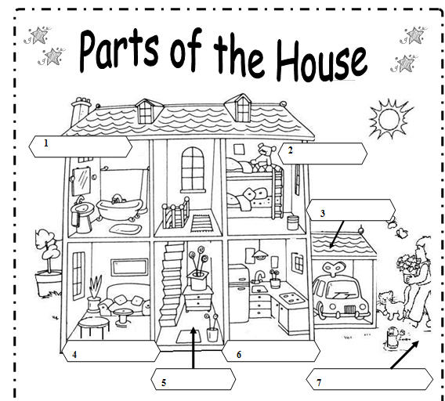

Part B. Look at the picture above and fill in the blanks.
- There is a car in the __________.
- There is a teddy in the __________.
- There are two butterflies in the __________.
- There are two pillows in the __________.
- There is a fridge in the __________.
- There is a mirror in the __________.

hall
Part C. Look at the picture again and fill in the blanks using the prepositions in the box.
above in front of upstairs below next to between behind downstairs on under in (x 8)

- There is a coffee table _______ the armchair _______ the living room.
- There are three pillows _______ the bed _______ the bedroom.
- There is a sink _______ the fridge _______ the kitchen.
- There is a living room _______.
- There is an armchair _______ the coffe table _______ the living room.
- There is a small bathroom _______.
- There is a plant _______ the window and the armchair _______ the living room.
- There is a dustbin _______ the window _______ the bedroom.
- There is a mirror ______ the sink _______ the bathroom.
- The child is working _______ the sun _______ the garden.

Part D. Circle the correct answer.
- I live in a small _______ in German.
- door b. city c. bottle d. season

- The classroom is _____________. Students can’t hear the teacher.
a. silent b. noisy c. messy d. perfect

- Jane’s house has a good _____. It is near stores and restaurants.
- bank b. location c. grammar d. child

- A good home has a big swimming ______.
- pool b. officer c. hotel d. gardener

- A good bed is ______.
- noisy b. false c. selfish d. comfortable

- My apartment is noisy , but it is _____ coffee shops and supermarkets.
- upstairs b. near c. downstairs d. at

- There is a baby in the room, so you can’t ______ here.
- remember b. smoke c. see d. like

- Jack and Lisa want to ______ a beach house in Çeşme this summer.
- pay b. draw c. rent d. describe

